**Secure Browser Settings**

If you are using **Microsoft Internet Explorer**, you can go to **Tools** and use the drop-down menu; then select **Options.** You will then see a screen much like the one shown in Figure 3.1. You can then select the third tab, labeled **Privacy.**

When you select that Privacy tab, you will see the screen shown in Figure 3.2. Notice the sliding bar on the left that lets you select various levels of general protection against cookies. It is recommended that you select Medium High as your level.

**Note the Advanced button** at the bottom of the screen. This button allows you to block or allow individual websites from creating cookies on your computer’s hard drive. Altering cookie settings on your machine is just one part of protecting your privacy, but it is an important part.

You probably also want to ensure that you have selected the In Private browsing option, also shown in Figure 3.2.

**Firefox**:

If you are **working with Firefox**, the process is similar. You select **Tools** from the drop-down menu, then select Options. You will then see the screen shown in Figure 3.3.

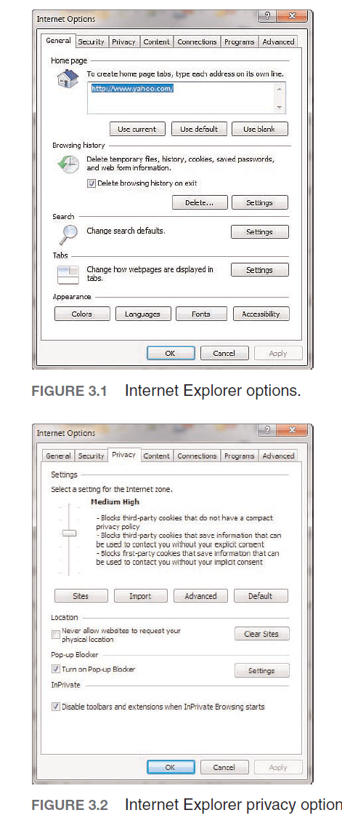



Notice the Privacy option and you will see a screen much like the one shown in Figure 3.4.



As you can see from Figure 3.4, there are a number of privacy settings for you to select, and they are self-explanatory. You can also select the Security tab and see the screen in Figure 3.5.



I recommend selecting High Security. Also, I would only allow first-party cookies. Third-party cookies are notorious for behaving in ways that violate user privacy. We will discuss cookies and spyware in much more detail in a later chapter, but the simple steps just examined can go a long way toward helping to secure your privacy.

Dealing with auction fraud involves a different set of precautions; here are four good ideas.

**1.** Only use reputable auction sites. The most well-known site is eBay, but any widely known, reputable site will be a safer gamble. Such auction sites tend to take precautions to prevent fraud and abuse.

**2.** If it sounds too good to be true, don’t bid.

**3.** Some sites actually allow you to read feedback other buyers have provided on a given seller. Read the feedback, and only work with reputable sellers.

**4.** When possible use a separate credit card, one with a low limit, for online auctions. That way, should your credit card be compromised, your liability is limited. Using your debit card is simply inviting trouble.

Online auctions can be a very good way to get valuable merchandise at low prices. However one must exercise some degree of caution when using these services.

Protecting yourself from online harassment also has its own guidelines:

**1.** If you use chat rooms, discussion boards, and so forth, do not use your real name. Set up a separate email account with an anonymous service, such as Yahoo!, Gmail, or Hotmail. Then use that account and a fake name online. This makes it very hard for an online stalker to trace back to you personally.

**2.** If you are the victim of online harassment, keep all the emails in both digital and printed format. Use some the investigative techniques we will explore later in this book to try and identify the perpetrator. If you are successful, then you can take the emails and the information on the perpetrator to law enforcement officials.

**3.** Do not, in any case, ignore cyber stalking. According to the Working to Halt Online Abuse website,14 19% of cyber stalking cases escalate to stalking in the real world.

It is not the intent of this chapter or of this book to make you frightened about using the Internet. My family routinely uses the Internet for entertainment, commerce, and informational purposes. One simply needs to exercise some caution when using the Internet.